St. Paul Ev. Lutheran Church, Muskego
Service Planning Guide

DATE: September 15-19, 2018 FESTIVAL/SERIES: Family Church
PREACHER: Peter Panitzke PRESIDING MINISTER: David Kuehl
ORGANIST:

FOCUS OF THE SERVICE: Deep down you have secretly envied and dreamed of being a pastor? OK, perhaps not. But the reality is, dad, mom, you are a pastor. God has called you to be the pastor(s) of your family. You are to watch out for and promote the spiritual health of everyone who lives under your roof. Wait a second, maybe our family isn’t mom, dad and kids. Maybe it’s our extended family, our small group, our close friends, our team at work, our Sunday school class. God has called us to be Jesus to someone in our lives. Worship Theme: The Pastor of the Family Church

ORDER OF WORSHIP: Divine Service 1

OPENING HYMN CW 255 Open Now Thy Gates of Beauty vv. 1-3

M In the name of the Father and of the Son and of the Holy Spirit.
C Amen

M Brothers and sisters in Christ, we have been called to declare the praises of him who called us out of darkness into his wonderful light to everyone around us, but especially to those within our families.
C Why then, do we so often fail to give God the honor and glory he deserves? Why is the spiritual nurturing of ourselves and our families so often forgotten or lost in the daily busyness of life?
M Because of the weakness of our sinful flesh. Because of our love of comfort and ease. Because we choose to put our faith and hope in the created thing rather than the Creator himself. Yet, God loved us despite our weakness and sin. He sent his Son to destroy sin’s power in our lives. Confident of God’s forgiving love in Christ, let us approach our heavenly Father with a true heart and confess our sins, asking him in the name of our Lord Jesus Christ to forgive us.
All Holy and merciful Father, I confess that I am by nature sinful, and that I have disobeyed you in my thoughts, words, and actions. I have done what is evil and failed to do what is good. For this I deserve your punishment both now and in eternity. But I am truly sorry for my sins, and trusting in my Savior Jesus Christ, I pray: Lord, have mercy on me, a sinner.

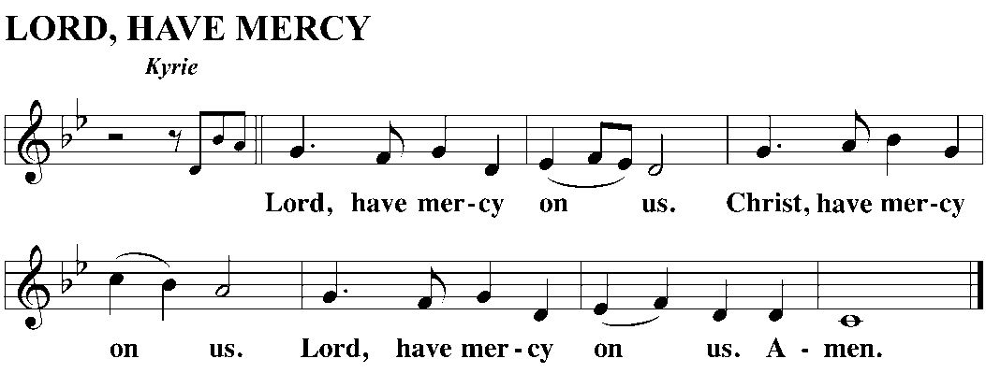
M God, our heavenly Father, has been merciful to us and has given his only Son to be the atoning sacrifice for our sins. Therefore, as a called servant of Christ and by his authority, I forgive you all your sins in the name of the Father, and of the Son and of the Holy Spirit.
C Amen.

M In the peace of forgiveness, let us praise the Lord.

SONG OF PRAISE CW 255 Open Now Thy Gates of Beauty vv. 4-5

PRAYER OF THE DAY
M Let us pray.
Father, we thank you for the gift of family. Your design for the family is beautiful: Parents passing the faith on to their children and nurturing them with your Word.
C Teach us, empower us, enable to be the best “family pastors” and the best students of your Word we can be.
M We pray through Jesus Christ, your Son, our Lord. He lives and reigns with you and the Holy Spirit, one God, now,
C and forever. Amen.

FIRST LESSON: Proverbs 3:1-18 (page 630)—Through every stage of life seek true wisdom, godly wisdom, and the Lord promises to make your paths straight.

PSALM OF THE DAY: Psalm 1 (page 64)—Lord, sink our family’s root deep in the living waters of your truth.

GOSPEL LESSON: Mark 9:42-50 (page 1013)—In dramatic fashion Jesus teaches us that our eternal welfare and the eternal welfare of others is priority number one.

HYMN OF THE DAY CW 512 Let Children Hear the Mighty Deeds

SERMON Ephesians 6:1-4

APOSTLES CREED

OFFERING
OFFERTORY

THE PRAYER OF THE CHURCH
M O Lord, our God, you are wise and powerful, good and gracious. Your mercies are new every morning. Each day you open your hand and provide for the needs of your children on earth.
C We praise you for every grace and blessing.
M Strengthen your Church in all the world. Let your comforting message of salvation in Christ Jesus be proclaimed to troubled souls everywhere.
C Use our ministries and offerings to extend your healing and your hope.
M We bring you our requests for the various structures of our society. Bless our national, state, and local governments.
C Grant us civil servants who are worthy of honor and respect.
M Grant prosperity to our businesses and industries. Give employers a sense of fairness toward their workers, and employees a feeling of joy and pride in their workmanship.
C Help us find satisfaction in all work well done.
M Invigorate the schools of our land. Give success to every effort that helps students read, think, and communicate in ways that will promote an informed and responsible citizenry. Arouse curious minds to discover the wonders of your created order.
C Give us teachers and students who pursue excellence.
M Strengthen the families of our country. Give fathers and mothers a renewed commitment to be good parents. Give children and young people the wisdom to regard their parents as your representatives.
C Lead us to love one another as you have loved us.

Special prayers and intercessions may follow.

M Hear us, Lord, as we bring you our private petitions.

Silent prayer.

M Gracious Father, we pray boldly as Jesus taught, with the confidence that you will hear and with the faith that you will respond for our welfare.
C Amen.

CLOSING HYMN CW 500 For Christian Home, O Lord, We Pray

CLOSING PRAYER
M Let us pray.
Lord Jesus, you have planted us like trees beside the streams of the refreshing waters of your love and grace.
C Help us to always delight in your Word and to yield abundant fruit in our lives.
M We pray, Jesus, in your name. You live and reign with the Father and the Holy Spirit, one God, now and forever.
C Amen.

BLESSING
M The Lord bless you and keep you.
The Lord make his face shine on you and be gracious to you.
The Lord look on you with favor and (+) give you peace.
C Amen.

