St. Paul’s Ev. Lutheran Church, Muskego

Service Planning Guide

Date: September 22-26, 2018 Sunday/Series: The Family Church

Preacher: Jeffrey Bonack Worship Leader: David Kuehl
Organist:

Order of Service: Morning Praise

“I’m the pastor of my family (whatever that family may look like)? Whoa! That sounds like a little more than I can handle. Where am I supposed to find the time? I don’t really know the Bible all that well. I don’t think this is for me.” Whatever obstacle we may think is there the same God who has called us to pastor will also give us the power and the ability. You are God’s masterpiece created in Christ Jesus to do good things which God prepared in advance for you to do. Worship Theme: The Power of the Family Church

BELLS

WELCOME/INTRODUCTION

HYMN CW 236 All Praise to God Who Reigns Above vv. 1-4

STAND

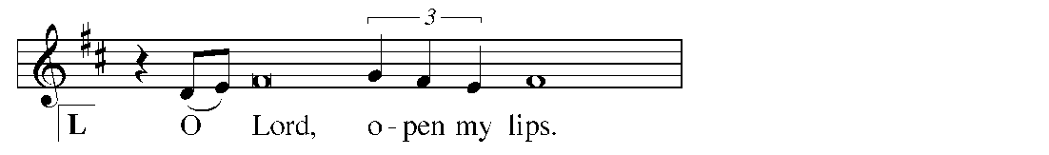
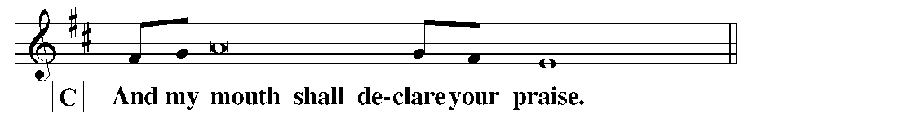
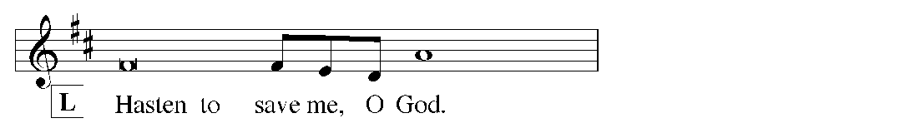
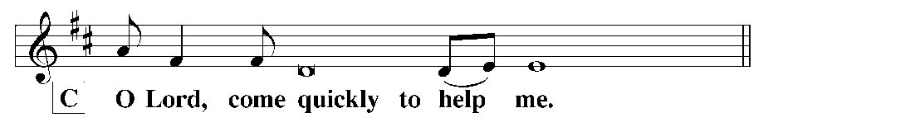
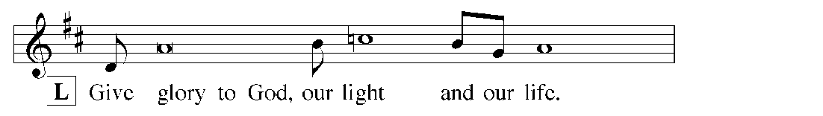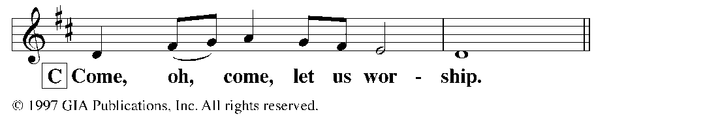
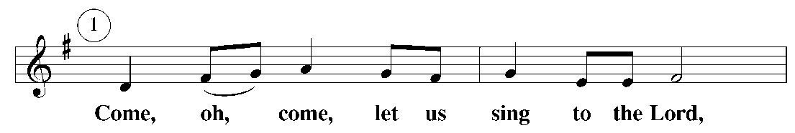
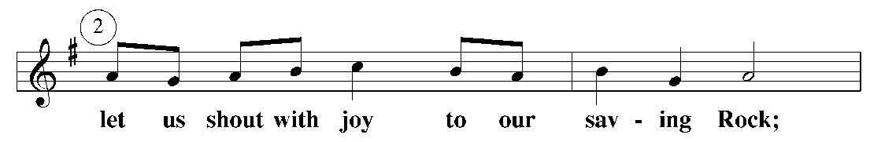
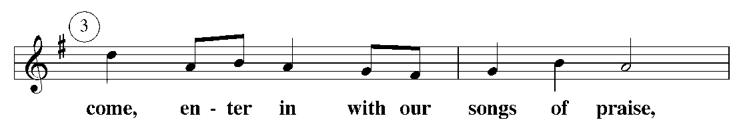
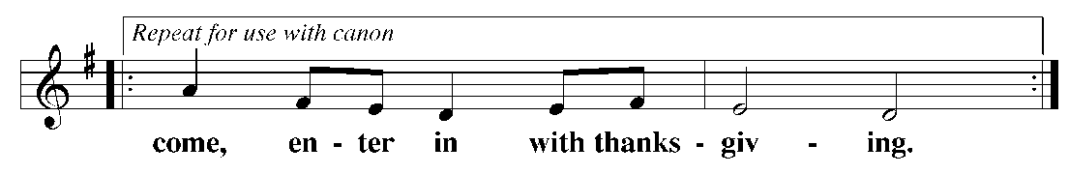
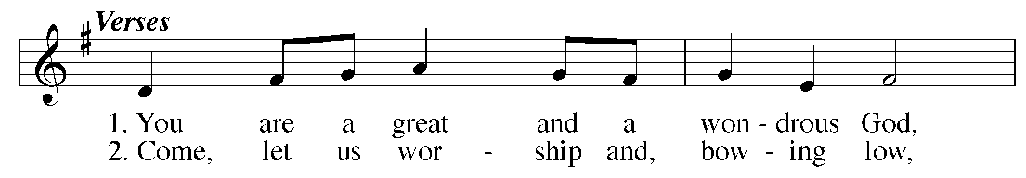
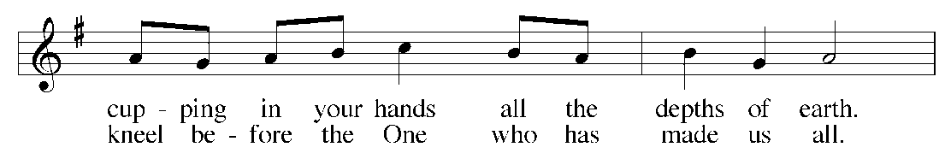
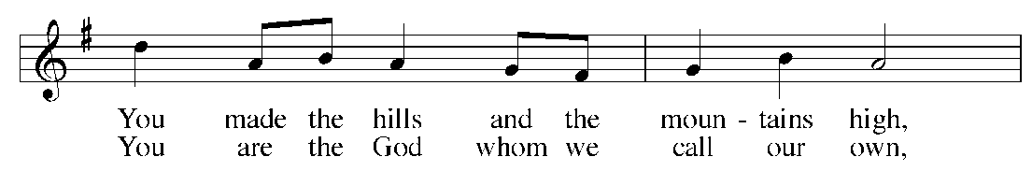
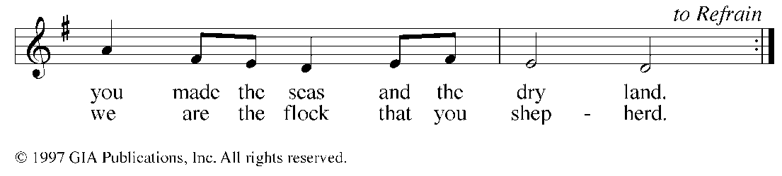

PRAYER OF THE DAY

M The peace of the Lord be with you.
C And also with you.

M Let us pray.
Father God, you have called us and you empower us to watch out for and nurture the members of our physical family as well as all those who are a part of our spiritual family.
C We are your handiwork, masterpieces, created in Christ Jesus to serve you by blessing others.
M When we don’t feel that we have the strength or ability to carry out this call
C Come to us through your Word and sacrament. Teach us and empower us to do the important tasks that you have prepared for us to do.
M We pray through Jesus Christ, your Son, our Lord. He lives and reigns with you and the Holy Spirit, one God, now
C and forever. Amen.

FIRST LESSON: Isaiah 40:21-31 (page 352)—Our Creator, our heavenly Father, knows best what we need. He gives strength to the weary and increases the power of the weak.

PSALM OF THE DAY: Psalm 46 (page 84)—God, our heavenly Father, is our refuge and strength, an ever-present help in trouble.

GOSPEL LESSON: Luke 11:5-13 (page 1041)—We have a heavenly Father who always knows how to answer our prayers in the way that is absolutely best for us.

HYMN OF THE DAY CW 536 Lord Jesus Christ, the Church’s Head

SERMON: Ephesians 1:15-2:10

CONFESSION OF FAITH (Te Deum)

[C] Refrain

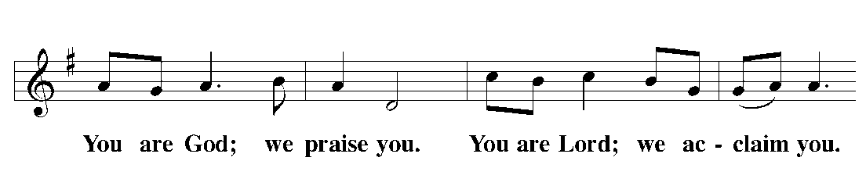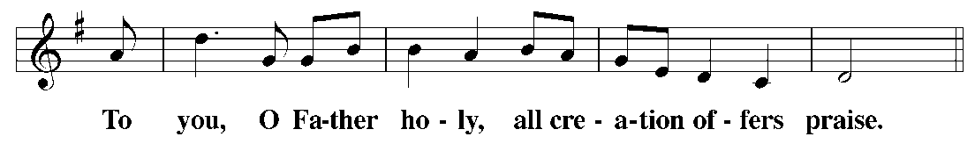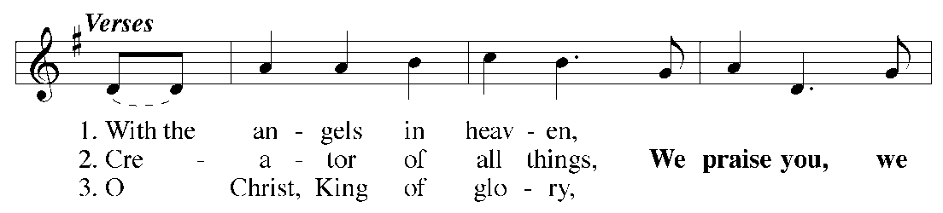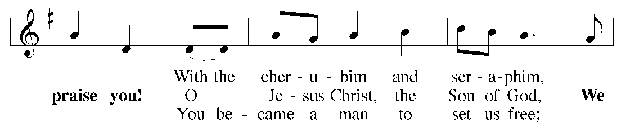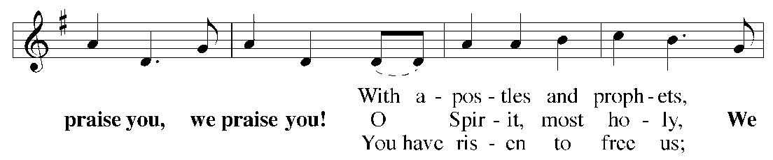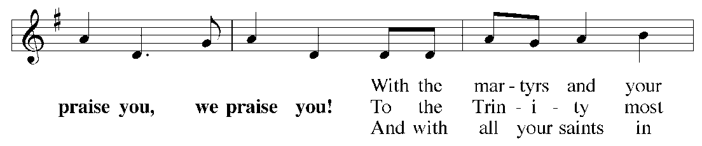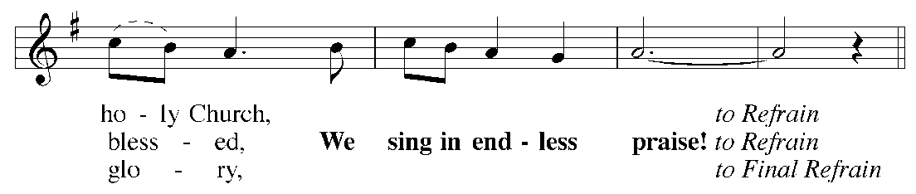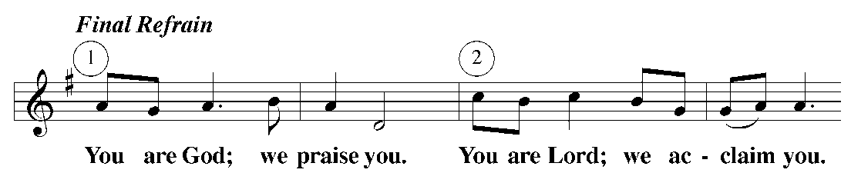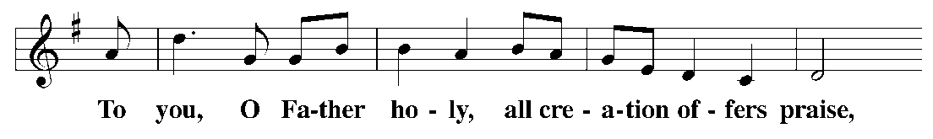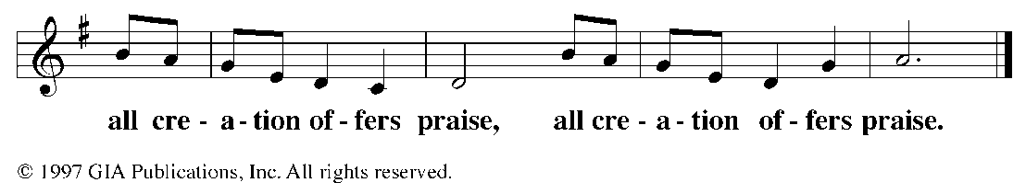

OFFERING

OFFERTORY 7:45: 9:15: LES K-1

PRAYER OF THE CHURCH

LORD’S PRAYER

HYMN CW 511 O Lord, Our God, Your Gracious Hand

CLOSING PRAYER

M Lord God, you have united our lives in Christ.

C Empower us to live and work together for your glory and the growth of your kingdom.

M You are the Lord forevermore.

C Amen.

BLESSING

