St. Paul’s Ev. Lutheran Church, Muskego

Service Planning Guide

Date: October 20-24, 2018 Sunday/Series: The Family Church

Preacher: Peter Panitzke Worship Leader: David Kuehl
Organist: Susan Oakes

Order of Service: Morning Praise

Who’s going to take the lead in your family church? Like David when confronted with the godless Goliath, someone needs to step out onto the battlefield. You are called to be the champion. You need to put on the full armor of God. You need to equip yourself to take your stand. Because if you don’t step into the void, Satan will. Worship Theme: The Champion of the Family Church

BELLS
WELCOME/INTRODUCTION

HYMN CW 474 Stand Up, Stand Up for Jesus

STAND

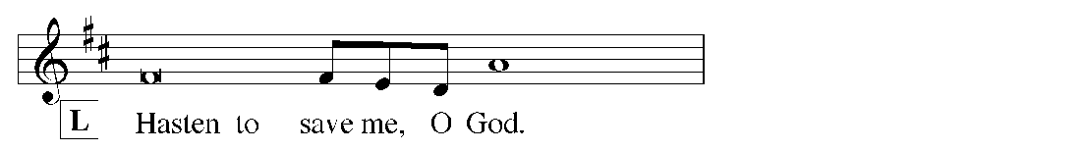
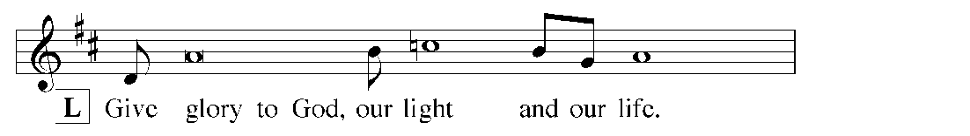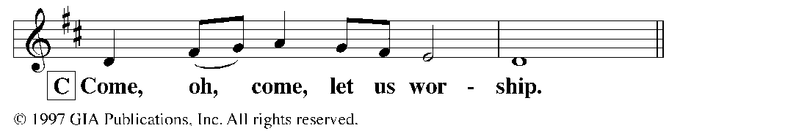
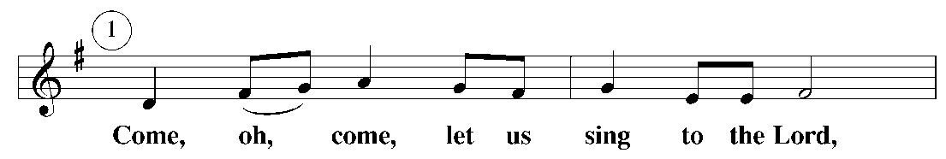
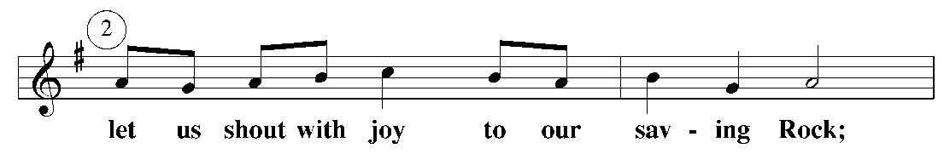
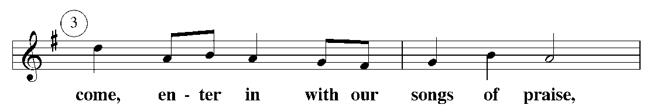
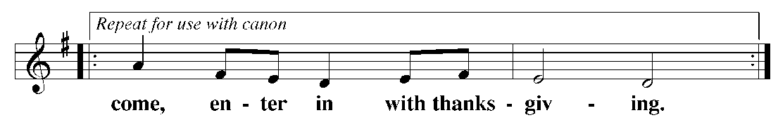
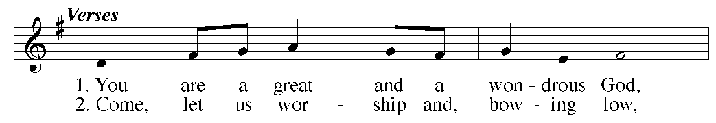
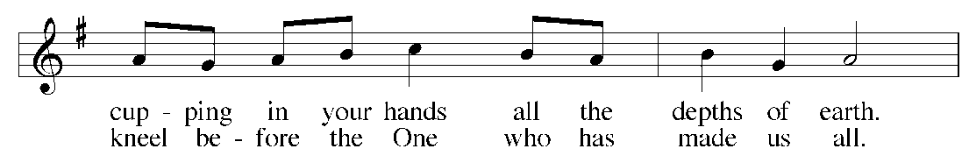
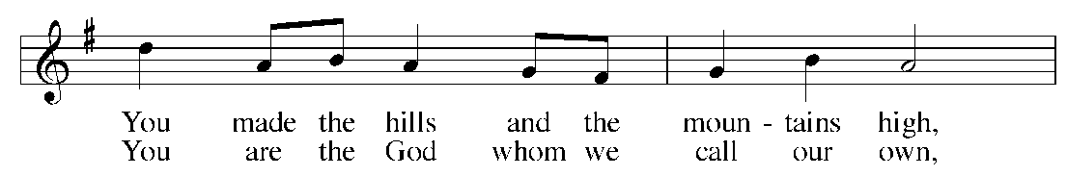
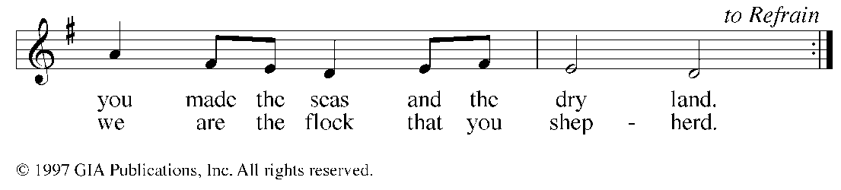

PRAYER OF THE DAY

M The peace of the Lord be with you.
C And also with you.

M Let us pray.
Lord God, heavenly Father, you have taught us that the greatest battles we face in life are spiritual, that our struggle is against the powers of darkness around us and within us.
C Equip us with the full armor of your love, grace and truth for these weapons are our only sure defense.
M We pray through Jesus Christ, your Son, our Lord. He lives and reigns with you and the Holy Spirit, one God, now and forever.
C Amen.

ANTHEM (9:15) LES K-8
FIRST LESSON: 1 Samuel 17:42-51 (page 285)— David faced Goliath clothed solely in the armor of the name of the Lord God Almighty.

PSALM OF THE DAY: Psalm 34 (page 80)—The angel of the Lord encamps around those who fear him and he delivers them.

GOSPEL LESSON: John 10:1-10 (page 1075)— Jesus is our Good Shepherd, With him by our side we will fear no evil!

HYMN OF THE DAY CW 455 Rise! To Arms! With Prayer Employ You

SERMON: Ephesians 6:10-18

CONGREGATIONAL AND INDIVIDUAL COMMITMENT TO THE FAMILY CHURCH

OFFERING

OFFERTORY Sat: 7:45 & 9:15:

PRAYER OF THE CHURCH
M Dear God, today we put on the full armor to guard our lives against attack.
C We put on the belt of truth to protect against lies and deception.
M We put on the breastplate of righteousness to protect our hearts from the temptations we battle.
C We put the gospel of peace on our feet, so we’re ready to take your light wherever you send us each new day.
M We choose to walk in the peace and freedom of your Spirit and not be overcome with fear and anxious thoughts.
C We take up your shield of faith that will extinguish all the flaming arrows and threats hurled our way by the enemy.
M We believe in your power to protect us and put our trust in you.
C We put on the helmet of salvation, which covers our minds and thoughts, reminding us we are children of the day, forgiven, set free, saved by the grace of Christ Jesus.
M We take up the sword of the Spirit, your very Word, the one offensive weapon given to us for battle, which has the power to demolish strongholds, alive, active, and sharper than any double-edged sword.

Special prayers and intercessions.

M Hear us, Lord, as we bring you our private petitions.

Silent prayer.

M Lord, empower to live as family, both in our nuclear family and in the wider family of the church.
C Help us to carry each other’s burden and in this way fulfill your law of love in our lives. Amen.

LORD’S PRAYER

HYMN O Church Arise

O church arise and put your armor on
Hear the call of Christ our Captain
For now the weak can say that they are strong
In the strength that God has given
With shield of faith and belt of truth
We'll stand against the devil's lies
An army bold whose battle cry is Love
Reaching out to those in darkness

Our call to war to love the captive soul
But to rage against the captor
And with the sword that makes the wounded whole
We will fight with faith and valor
When faced with trials on every side
We know the outcome is secure
And Christ will have the prize for which He died
An inheritance of nations

Come see the cross where love and mercy meet
As the Son of God is stricken
Then see His foes lie crushed beneath His feet
For the Conqueror has risen
And as the stone is rolled away
And Christ emerges from the grave
This victory march continues till the day
Every eye and heart shall see Him

So Spirit come put strength in every stride
Give grace for every hurdle
That we may run with faith to win the prize
Of a servant good and faithful
As saints of old still line the way
Retelling triumphs of His grace
We hear their calls and hunger for the day
When with Christ we stand in glory

Keith Getty | Stuart Townend. © 2005 Thankyou Music (Admin. by Capitol CMG Publishing) CCLI License # 1466410

CLOSING PRAYER

M Lord, you are the Messiah, the Son of the living God.

C When Satan accuses us, when doubts and fears fill our hearts, keep the eyes of our faith focused you, our Savior and Redeemer.

M You are the Lord forevermore.

C Amen.

BLESSING

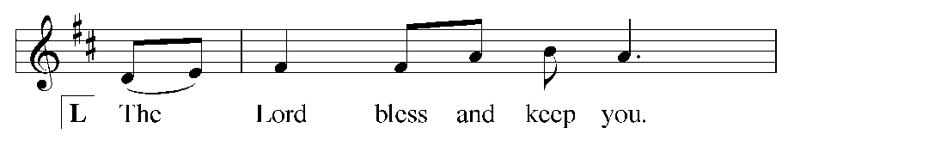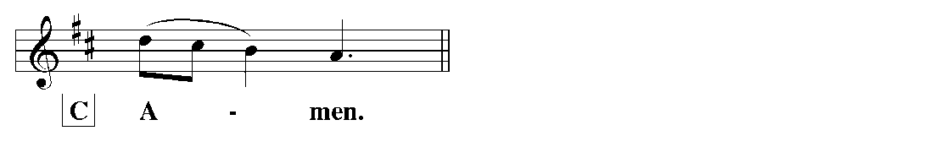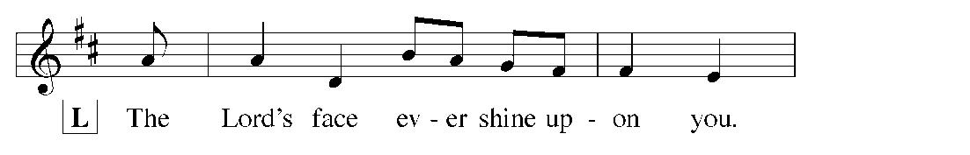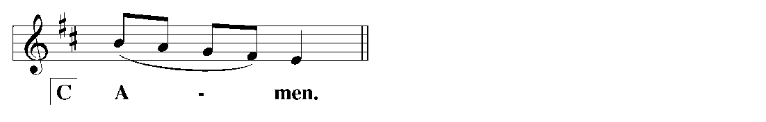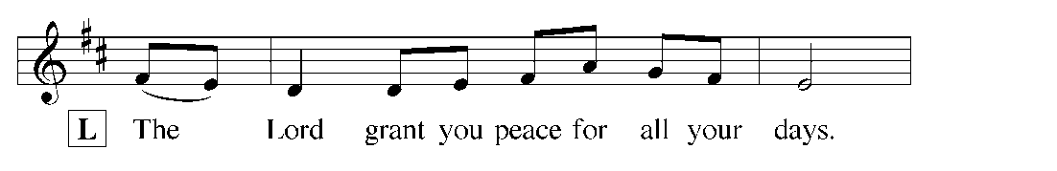

- Dedication Sunday plans – October 21
  - During worship service
  - Check back in January
  - Darwin and Gladys Dusseau – prayed over on their 70th anniversary
  - I hear nuclear family – we are going to make this pledge. What if divorced dad not present.
  - Provide a devotional book…anyone who sees yourself as a spiritual shepherd
  - Book mark – Lord help me to live in the moment… Give everyone a bookmark with verses… prayer… reminded to be repetitive daily thing
  - What works for our family. Highs and Lows at dinners. Opening our hearts.. have good conversation at dinner time. This works for us.
  - Not so much church gave me something to do. Now what is the rythym that works for us as a family.
  - Do we want them to come up to the altar? “I’ve thought about it… this is how I apply?” How do you engage the children? Cross sticker on family window. A visual reminder for me to think.
  - Form – this is what I want to rededicate. Pray over those commitments.
  - Visual thing… I put my finger print on ink… filling up this image – visual of the family of church.
  - Family Shield… Kristen Gjerdset working on church family shield.

Prep people… there is a going to be a commissioning… two weeks before…
In message and worship folder…

