St. Paul Ev. Lutheran Church, Muskego
Service Planning Guide

DATE: October 27-31, 2018 SUNDAY/FESTIVAL: The Family Church
PREACHER: Peter Panitzke PRESIDING MINISTER: David Kuehl
ORGANIST: Darik Mischke

WORSHIP THEME: As parents, we love to see our children succeed. In fact, their success often fills us with more joy than our own. What is the ultimate success of the church family? It’s seeing each member of the family grow and shine. It’s watching them not only learn to walk, but to run the race and ultimately, victoriously cross the finish line. How we look forward to the day when this life with all its struggles is past and, having fought the good fight, we join with the whole family of God in the eternal celebration! Worship Theme: The Joy of the Family Church

ORDER OF WORSHIP: Divine Service I (Christian Worship Supplement)
BELLS/WELCOME

OPENING HYMN: CW 259 When All Your Mercies, O My God

M In the name of the Father and of the + Son and of the Holy Spirit.
C Amen.

M Brothers and sisters in Christ, in his letter to the Philippians Paul calls us to shine like stars as we hold firmly to the word of life.
C Then he will be able to boast on the day of Christ that he did not run or labor in vain (Philippians 2:15,16).
M Paul sees as his great calling the spiritual training of his faith family so that they can shine God’s love in Christ into the world around them. This is our great calling as well. Yet, who of us can live up to this great task? Acknowledging our weakness and failures, as well as our need to be renewed through the power of confession and forgiveness, we come before our God in humble honesty and confess our sins.
C Holy and merciful Father, I confess that I am by nature sinful, and that I have disobeyed you in my thoughts, words, and actions. I have done what is evil and failed to do what is good. For this I deserve your punishment both now and in eternity. But I am truly sorry for my sins, and trusting in my Savior Jesus Christ, I pray: Lord, have mercy on me, a sinner.

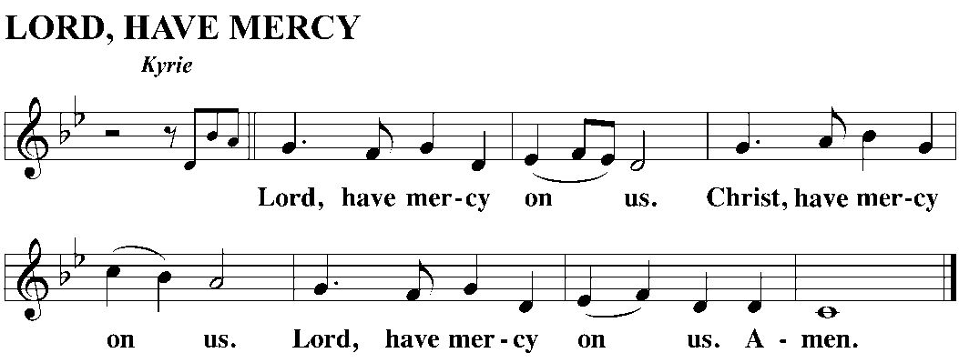

M God, our heavenly Father, has been merciful to us and has given his only Son to be the atoning sacrifice for our sins. Therefore, as a called servant of Christ and by his authority, I forgive you all your sins in the name of the Father, and of the Son and of the Holy Spirit.
C Amen.

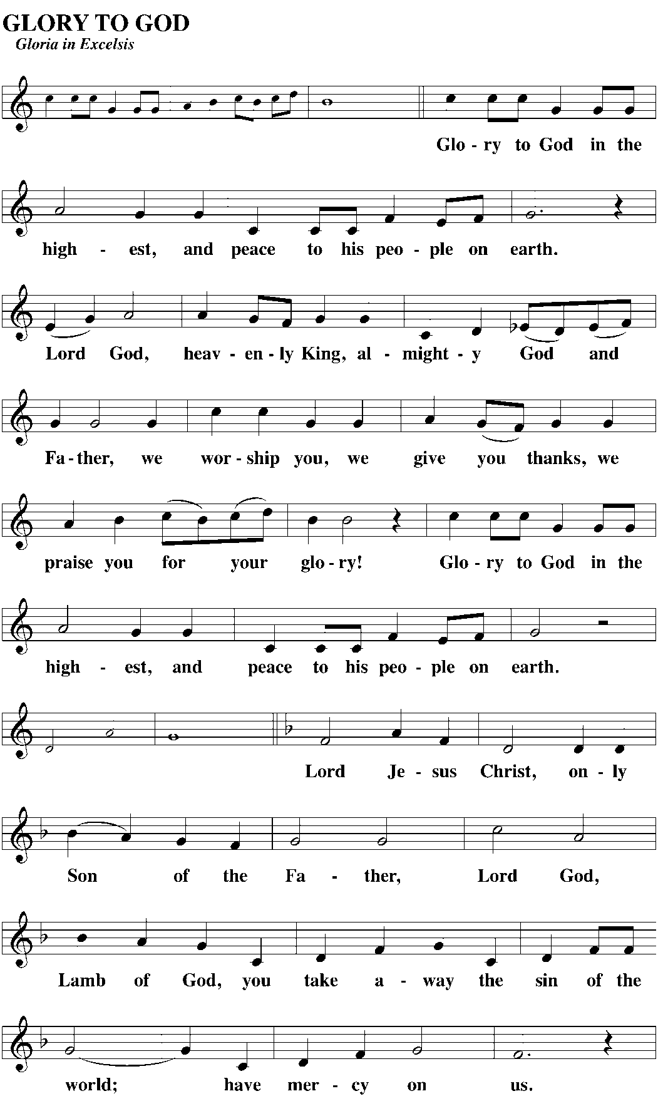

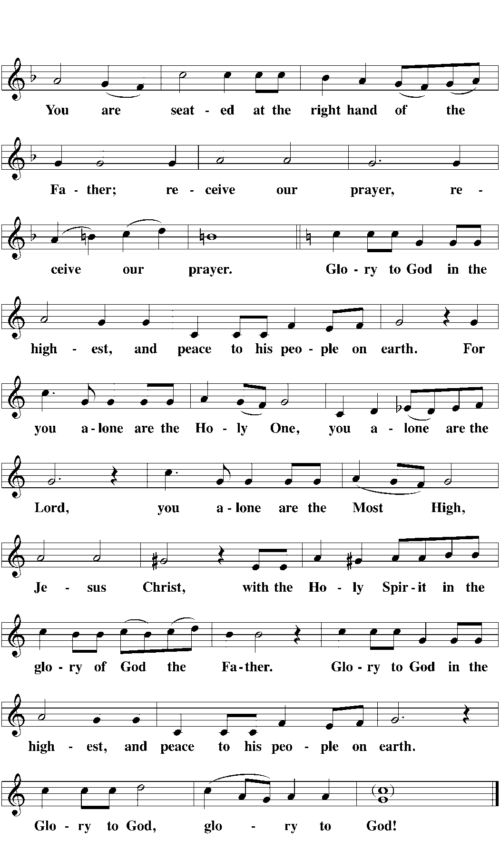

PRAYER OF THE DAY
M Let us pray.
Father God, you are eternal. You have no beginning and no end.
C You have made us a part of your family—a family that will endure forever.
M As we make our journey through life, keep us focused on the ultimate goal.
C Empower us to live spiritually wise with our eyes on eternity.
M We pray through Jesus Christ, your Son, our Lord. He lives and reigns with you and the Holy Spirit, one God, now
C and forever. Amen.

THE WORD

FIRST LESSON: Isaiah 65:17-25 (page 748)—In picturesque Old Testament language, the Lord gives us a glimpse into the life we will ultimately share in heaven.

VERSE OF THE DAY
M Alleluia. Alleluia. Whoever finds their life will lose it, and whoever loses their life for my sake will find it. Alleluia. (Matthew 10:39 cf. NIV)

GOSPEL LESSON: Matthew 25:1-13 (page 993)—Jesus is coming soon! Let’s make sure our families are ready.

NICENE CREED

HYMN OF THE DAY CW 515 Shepherd of Tender Youth

SERMON: 2 Corinthians 1:3-5

OFFERING/OFFERTORY

PRAYER OF THE CHURCH

THE LORD’S PRAYER

COMMUNION LITURGY (DIVINE SERVICE I)

DISTRIBUTION CW 606 For Me To Live Is Jesus
CW 417 I’m But a Stranger Here

CLOSING PRAYER
M Jesus, you came to us today and poured out the riches of your love and grace in your Word
and sacrament.
C In you we truly have all that we need and more!
M As we go out into the world, empower us as your forgiven children to give witness to the truth that we are yearning for a new and better world in heaven.
C May the light of your love shine in us and through us.
M We bless you now and forevermore.
C Amen.

BLESSING

